1. Demonstration of SINGLE FORK () System Call.

#include <stdio.h>
#include <sys/types.h>
#include <unistd.h>
int main(){
fork();
printf("Hello world\n");
}

OUTPUT

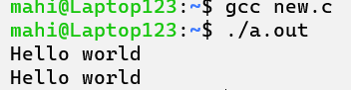

2. Parent Process Computes the SUM OF EVEN and Child Process computes the
sum of ODD NUMBERS using fork.

#include <stdio.h>
#include <sys/types.h>
#include <unistd.h>
int main(){
pid_t pid;
pid = fork();
int n = 10;
int sum_o = 0;
int sum_e = 0;
if(pid==0){
printf("I am child, my PID=%d and PPID=%d\n", getpid(), getppid());
for(int i=1; i<n; i+=2){
sum_o += i;
}
printf("Odd: %d\n", sum_o);
}
else{
printf("I am parent and my PID=%d\n", getpid());
for(int i=2; i<n; i+=2){
sum_e += i;
}
printf("Even: %d\n", sum_e);
}
printf("Terminating PID=%d\n", getpid());
}

OUTPUT

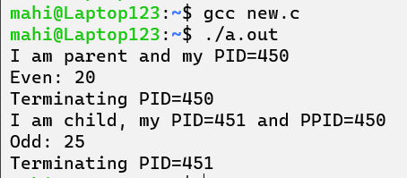
3. Demonstration of WAIT () System Call.

#include <stdio.h>
#include <sys/types.h>
#include <unistd.h>

int main(){
pid_t pid;
pid = fork();
if(pid==0){
printf("I am child, my PID=%d and PPID=%d\n", getpid(), getppid());
sleep(10);
}
else{
printf("I am parent and my PID=%d\n", getpid());
wait(NULL);
printf("I am a parent.\n");
}
printf("Terminating PID=%d\n", getpid());
}

OUTPUT

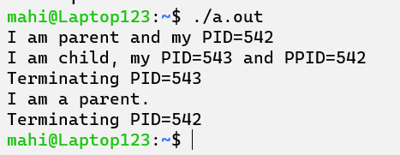
4. Implementation of ORPHAN PROCESS & ZOMBIE PROCESS.

Orphan

#include <stdio.h>
#include <sys/types.h>
#include <unistd.h>

int main(){
pid_t pid;
pid = fork();
if(pid==0){
sleep(10);
printf("I am child, my PID=%d and PPID=%d\n", getpid(), getppid());
}
else{
printf("I am parent and my PID=%d\n", getpid());
}
printf("Terminating PID=%d\n", getpid());
return 0;
}

OUTPUT

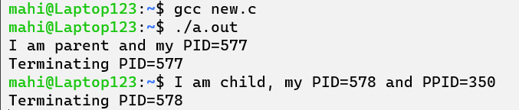
Zombie

#include<sys/types.h>
#include<stdio.h>
int main()
{
pid_t pid;
pid = fork();
if(pid == 0){
printf("I am child and My PID is %d and My Parent PID is %d\n",getpid(), getppid());
}
else{
printf("I am Parent and my PID is %d\n", getpid());
sleep(50);
}
}

OUTPUT

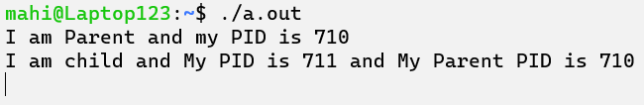
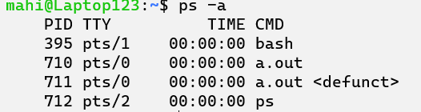
6. WAP to implement FIRST COME FIRST SERVED SCHEDULING ALGO.
Calculate the average turnaround time and average waiting time.

#include <stdio.h>
void findWaitingTime(int n, int bt[], int wt[]){
wt[0] = 0;
for(int i = 1; i<n; i++)
wt[i] = wt[i-1]+bt[i-1];
}
void findTurnaroundTime(int n, int bt[], int wt[], int tat[]){
for(int i = 0; i<n; i++)
tat[i] = bt[i]+wt[i];
}
void findAvgTime(int n, int bt[]){
int wt[n], tat[n], total_wt = 0, total_tat = 0;
findWaitingTime(n, bt, wt);
findTurnaroundTime(n, bt, wt, tat);
printf("PROCESSES\tBURST TIME\tWAITING TIME\tTURN AROUND TIME\n");
for(int i = 0; i<n; i++){
total_wt = total_wt+wt[i];
total_tat = total_tat+tat[i];
printf("%d\t\t%d\t\t%d\t\t%d\n", i+1, bt[i], wt[i], tat[i]);
}
float s = (float)total_tat/(float)n;
float t = (float)total_wt/(float)n;
printf("Average waiting/response time = %f\n", t);
printf("Average turnaround time = %f\n", s);
}
int main(){
int n;
printf("Enter number of processes: ");
scanf("%d", &n);
int burst_time[n];
for(int i = 0; i<n; i++){
printf("BURST TIME FOR PROCESS %d: ", i+1);
scanf("%d", &burst_time[i]);
}
findAvgTime(n, burst_time);
}

OUTPUT

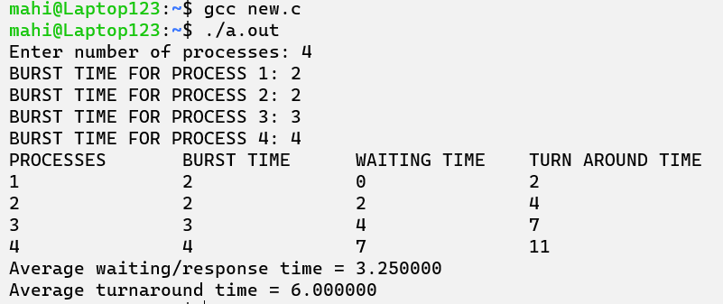
7. WAP to implement SHORTEST JOB FIRST SCHEDULING ALGO. Calculate the
average turnaround time and average waiting time and average response time.

#include <stdio.h>
#include <stdlib.h>
typedef struct Process{
int id;
int bt;
int tat, wt;
} Process;
void swap(Process* px, Process* py){
Process tmp = *px;
*px=*py;
*py = tmp;
}
void sort(Process** p, int n){
for(int i = 0; i<n-1; i++){
for(int j = 0; j<n-i-1; j++){
if((*p[j]).bt > (*p[j+1]).bt)
swap(p[j], p[j+1]);
}
}
}
void calc(Process** p, int n){
(*p[0]).wt=0;

for(int i = 1; i<n; i++){
(*p[i]).wt=(*p[i-1]).wt+(*p[i-1]).bt;
}

for(int i = 0; i<n; i++){
(*p[i]).tat=(*p[i]).wt+(*p[i]).bt;
}
}
int main(){
int n;
printf("No. of processes: ");
scanf("%d", &n);
Process** p = (Process **)malloc(sizeof(Process*)*n);
for(int i = 0; i<n; i++){
p[i] = (Process *)malloc(sizeof(Process));
p[i]->id = i+1;
printf("\nBurst time for process %d: ", i+1);
scanf("%d", &p[i]->bt);
}
sort(p,n);
calc(p,n);
printf("\nPROCESSES\tBURST TIME\tWAITING TIME\tTURN AROUND TIME\n");
float avgW = 0;
float avgT = 0;
float avgR = 0;
for(int i = 0; i<n; i++){
printf("%d\t\t%d\t\t%d\t\t%d\n", p[i]->id, p[i]->bt, p[i]->wt, p[i]->tat);
avgW += (float)p[i]->wt;
avgT += (float)p[i]->tat;
}
avgW /= n;
avgT /= n;
printf("Average waiting time: %f\nAverage turnaround time: %f\nAverage response time: %f\n", avgW, avgT, avgW);
}
OUTPUT

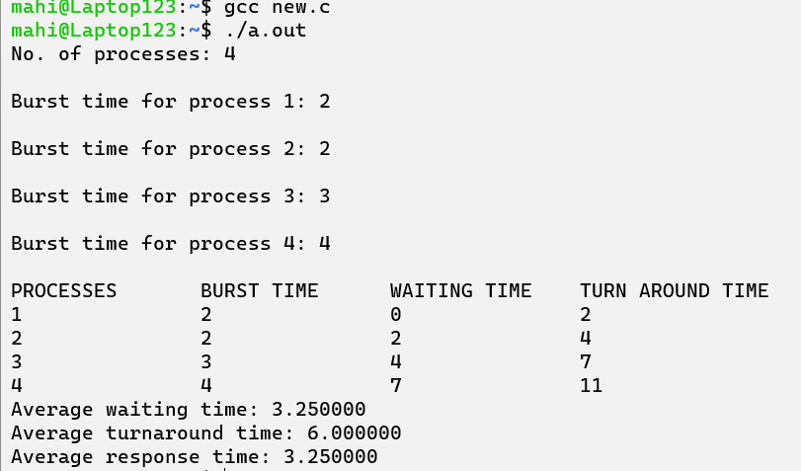
8. WAP to implement PRIORITY SCHEDULING ALGO. Calculate the average
turnaround time and average waiting time and average response time.

#include <stdio.h>
typedef struct Process{
int pid;
int bt;
int priority;
} Process;
void findWaitingTime(Process proc[], int n, int wt[]){
wt[0] = 0;
for (int i = 1; i < n; i++)
wt[i] = proc[i - 1].bt + wt[i - 1];
}
void findTurnAroundTime(Process proc[], int n, int wt[], int tat[]){
for (int i = 0; i < n; i++)
tat[i] = proc[i].bt + wt[i];
}
void findavgTime(Process proc[], int n){
int wt[n], tat[n], total_wt = 0, total_tat = 0;
findWaitingTime(proc, n, wt);
findTurnAroundTime(proc, n, wt, tat);
printf("\nProcesses Burst time Waiting time Turn around time\n");
for (int i = 0; i < n; i++)
{
total_wt = total_wt + wt[i];
total_tat = total_tat + tat[i];
printf(" %d\t\t%d\t %d\t\t %d\n", proc[i].pid, proc[i].bt, wt[i], tat[i]);
}
printf("\nAverage waiting time = %f", 1.0*total_wt / n);
printf("\nAverage turn around time = %f\n", 1.0*total_tat / n);
}
void priorityScheduling(Process proc[], int n){
for (int i = 0; i < n - 1; i++){
for (int j = 0; j < n - i - 1; j++){
if (proc[j].priority > proc[j + 1].priority){
Process temp = proc[j];
proc[j] = proc[j + 1];
proc[j + 1] = temp;
}
}
}
printf("Order in which processes get executed \n");
for (int i = 0; i < n; i++)
printf("%d ", proc[i].pid);
findavgTime(proc, n);
}
int main() {
int n;
printf("Enter the number of processes: ");
scanf("%d", &n);
Process proc[n];
for (int i = 0; i < n; i++) {
proc[i].pid = i+1;
printf("Burst Time for %d: ", i+1);
scanf("%d", &proc[i].bt);
printf("Priority for %d: ", i+1);
scanf("%d", &proc[i].priority);
}
priorityScheduling(proc, n);
return 0;
}
OUTPUT

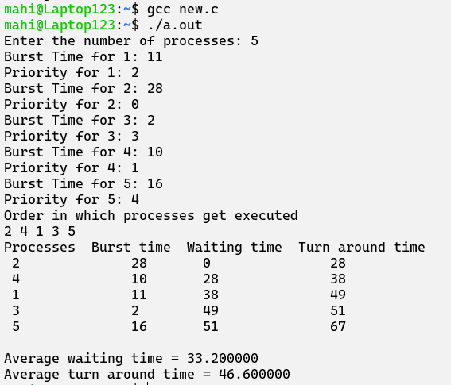
9. Implementation of ROUND ROBIN SCHEDULING ALGORITHM. Calculate the
average turnaround time and average waiting time and average response time.

#include <stdio.h>
void findWaitingTime(int processes[], int n, int bt[], int wt[], int quantum){
int rem_bt[n];
for (int i = 0; i < n; i++)
rem_bt[i] = bt[i];
int t = 0;
while (1){
int done = 1;
for (int i = 0; i < n; i++){
if (rem_bt[i] > 0){
done = 0;
if (rem_bt[i] > quantum){
t += quantum;
rem_bt[i] -= quantum;
}
else{
t = t + rem_bt[i];
wt[i] = t - bt[i];
rem_bt[i] = 0;
}
}
}
if (done == 1)
break;
}
}
void findTurnAroundTime(int processes[], int n, int bt[], int wt[], int tat[]){
for (int i = 0; i < n; i++)
tat[i] = bt[i] + wt[i];
}
void findavgTime(int processes[], int n, int bt[], int quantum){
int wt[n], tat[n], total_wt = 0, total_tat = 0;
findWaitingTime(processes, n, bt, wt, quantum);
findTurnAroundTime(processes, n, bt, wt, tat);
printf("PN\t \tBT \tWT \tTAT\n");
for (int i = 0; i < n; i++){
total_wt = total_wt + wt[i];
total_tat = total_tat + tat[i];
printf(" %d\t\t%d\t %d\t\t %d\n", processes[i], bt[i], wt[i], tat[i]);
}
printf("Average waiting time = %.2f\n", (float)total_wt / (float)n);
printf("Average turnaround time = %.2f\n", (float)total_tat / (float)n);
printf("Average response time = %.2f\n", (float)total_wt / (float)n);
}
int main(){
int n;
printf("Enter the number of processes: ");
scanf("%d", &n);
int processes[n];
int burst_time[n];
for (int i = 0; i < n; i++){
printf("Enter burst time for Process %d: ", i + 1);
scanf("%d", &burst_time[i]);
processes[i] = i + 1;
}
int quantum;
printf("Enter time quantum: ");
scanf("%d", &quantum);
findavgTime(processes, n, burst_time, quantum);
return 0;
}

OUTPUT

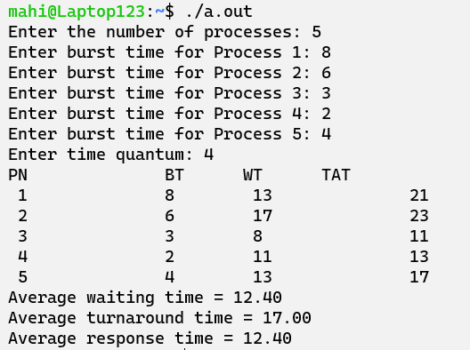
10. Implementation of SHORTEST REMAINING TIME FIRST ALGORITHM. Calculate the average turnaround time and average waiting time and average response time.

#include <stdio.h>
#include <limits.h>
#include <stdbool.h>
typedef struct Process{
int pid;
int bt;
int art;
} Process;
void findWaitingTime(Process proc[], int n, int wt[]){
int rt[n];
for (int i = 0; i < n; i++)
rt[i] = proc[i].bt;
int complete = 0, t = 0, minm = INT_MAX;
int shortest = 0, finish_time;
bool check = false;
while (complete != n){
for (int j = 0; j < n; j++){
if ((proc[j].art <= t) && (rt[j] < minm) && rt[j] > 0){
minm = rt[j];
shortest = j;
check = true;
}
}
if (check == false){
t++;
continue;
}
rt[shortest]--;
minm = rt[shortest];
if (minm == 0)
minm = INT_MAX;
if (rt[shortest] == 0){
complete++;
check = false;
finish_time = t + 1;
wt[shortest] = finish_time -proc[shortest].bt -proc[shortest].art;
if (wt[shortest] < 0)
wt[shortest] = 0;
}
t++;
}
}
void findTurnAroundTime(Process proc[], int n, int wt[], int tat[]){
for (int i = 0; i < n; i++)
tat[i] = proc[i].bt + wt[i];
}
void findavgTime(Process proc[], int n){
int wt[n], tat[n], total_wt = 0,total_tat = 0;
findWaitingTime(proc, n, wt);
findTurnAroundTime(proc, n, wt, tat);
printf(" P\t\tBT\t\tWT\t\tTAT\t\t\n");
for (int i = 0; i < n; i++){
total_wt = total_wt + wt[i];
total_tat = total_tat + tat[i];
printf(" %d\t\t%d\t\t %d\t\t %d\n", proc[i].pid, proc[i].bt, wt[i], tat[i]);
}
printf("Average waiting time: %f\n", (float)total_wt / n);
printf("Average turn around time: %f\n", (float)total_tat / n);
}
int main(){
int n;
scanf("%d", &n);
Process p[n];
for (int i = 0; i < n; i++){
p[i].pid = i + 1;
printf("\nEnter arrival time for process %d: ", i + 1);
scanf("%d", &p[i].art);
printf("Enter burst time for process %d: ", i + 1);
scanf("%d", &p[i].bt);
}
findavgTime(p, n);
return 0;
}
OUTPUT

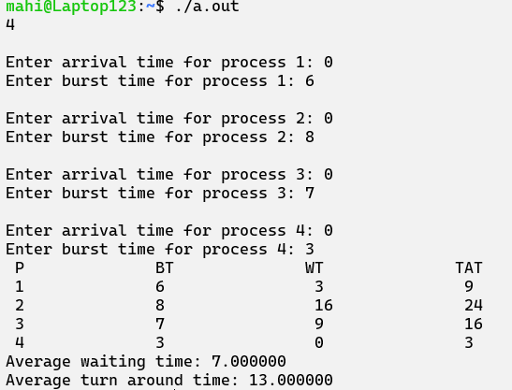
11. Implementation of OPTIMAL PAGE REPLACEMENT POLICY. Calculate the
number of misses for a given sequence of page numbers. (sequence and frame
number will be given by user).

#include <stdio.h>
#include <stdbool.h>
#include <string.h>
void optimalPage(int pg[], int n, int size)
{
int fr[size];
memset(fr, -1, sizeof(fr));
int hit = 0;
for (int i = 0; i < n; i++)
{
bool found = false;
for (int j = 0; j < size; j++)
{
if (fr[j] == pg[i])
{
hit++;
found = true;
break;
}
}
if (found)
continue;
bool emptyFrame = false;
for (int j = 0; j < size; j++)
{
if (fr[j] == -1)
{
fr[j] = pg[i];
emptyFrame = true;
break;
}
}
if (emptyFrame)
continue;
int farthest = -1, replaceIndex = -1;
for (int j = 0; j < size; j++)
{
int k;
for (k = i + 1; k < n; k++)
{
if (fr[j] == pg[k])
{
if (k > farthest)
{
farthest = k;
replaceIndex = j;
}
break;
}
}
if (k == n)
{
replaceIndex = j;
break;}
}
fr[replaceIndex] = pg[i];
}
printf("No. of hits = %d\n", hit);
printf("No. of misses = %d\n", n - hit);
}
int main()
{
int n, size;
printf("Enter the number of pages: ");
scanf("%d", &n);
int pg[n];
printf("Enter the page numbers: ");
for (int i = 0; i < n; i++)
{
scanf("%d", &pg[i]);
}
printf("Enter the size: ");
scanf("%d", &size);
optimalPage(pg, n, size);
return 0;
}

OUTPUT

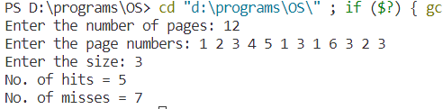
12. Implementation of LRU PAGE REPLACEMENT POLICY. Calculate the number of misses for a given sequence of page numbers. (sequence and frame number will be given by user).

#include <stdio.h>
#include <limits.h>
int checkHit(int incomingPage, int queue[], int occupied)
{
for (int i = 0; i < occupied; i++)
{
if (incomingPage == queue[i])
return 1;
}
return 0;
}
void printFrame(int queue[], int occupied)
{
for (int i = 0; i < occupied; i++)
printf("%d\t\t\t", queue[i]);
}
int main()
{
int n;
printf("Enter no of pages:");
scanf("%d", &n);
int incomingStream[n];
printf("Enter page nos:");
for (int i = 0; i < n; i++)
{
scanf("%d", &incomingStream[i]);
}
int frames;
printf("Enter no of frames:");
scanf("%d", &frames);
int queue[n];
int distance[n];
int occupied = 0;
int pagefault = 0;
printf("Page\t\t Frame1 \t\t Frame2 \t\t Frame3\n");
for (int i = 0; i < n; i++)
{
printf("%d: \t\t", incomingStream[i]);
if (checkHit(incomingStream[i], queue, occupied))
printFrame(queue, occupied);
else if (occupied < frames)
{
queue[occupied] = incomingStream[i];
pagefault++;
occupied++;
printFrame(queue, occupied);
}
else
{
int max = INT_MIN;
int index;
for (int j = 0; j < frames; j++)
{
distance[j] = 0;
for (int k = i - 1; k >= 0; k--)
{
++distance[j];
if (queue[j] == incomingStream[k])
break;
}
if (distance[j] > max)
{
max = distance[j];
index = j;
}
}
queue[index] = incomingStream[i];
printFrame(queue, occupied);
pagefault++;
}
printf("\n");
}
printf("Page Fault: %d\n", pagefault);
return 0;
}
OUTPUT

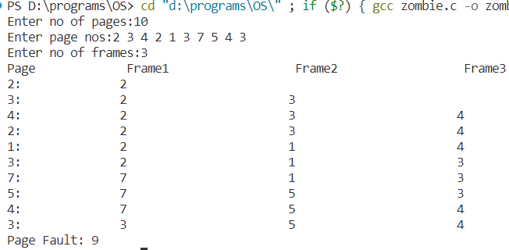
13. WAP to implement FCFS disk scheduling algorithm. Calculate the total seek time.

#include <stdio.h>
#include <stdlib.h>
int main()
{
int n, i, head, total_seek = 0;
printf("Enter total number of disk requests: ");
scanf("%d", &n);
int requests[n];
printf("Enter the requests sequence: ");
for (i = 0; i < n; ++i)
{
scanf("%d", &requests[i]);
}
printf("Enter the initial head position: ");
scanf("%d", &head);
printf("Seek Sequence: %d", head);
for (i = 0; i < n; ++i)
{
total_seek += abs(head - requests[i]);
printf(" -> %d", requests[i]);
head = requests[i];
}
printf("\nTotal number of seek operations: %d\n", total_seek);
return 0;
}

OUTPUT

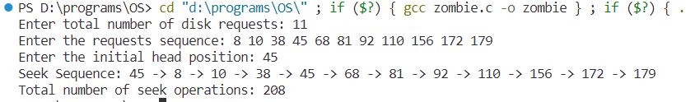
14. WAP to implement Scan and C-scan disk scheduling algorithm. Calculate the total seek time.

// SCAN
#include <stdio.h>
int absoluteValue(int);
void main()
{
int queue[25], n, headposition, i, j, k, seek = 0, maxrange,difference, temp, queue1[20], queue2[20], temp1 = 0, temp2 = 0;
float averageSeekTime;
printf("Enter the maximum range of Disk: ");
scanf("%d", &maxrange);
printf("Enter the number of queue requests: ");
scanf("%d", &n);
printf("Enter the initial head position: ");
scanf("%d", &headposition);
printf("Enter the disk positions to be read(queue): ");
for (i = 1; i <= n; i++)
{
scanf("%d", &temp);
if (temp > headposition)
{
queue1[temp1] = temp;
temp1++;
}
else
{
queue2[temp2] = temp;
Temp2++;
}
}
for (i = 0; i < temp1 - 1; i++)
{
for (j = i + 1; j < temp1; j++)
{
if (queue1[i] > queue1[j])
{
temp = queue1[i];
queue1[i] = queue1[j];
queue1[j] = temp;
}
}
}
for (i = 0; i < temp2 - 1; i++)
{
for (j = i + 1; j < temp2; j++)
{
if (queue2[i] < queue2[j])
{
temp = queue2[i];
queue2[i] = queue2[j];
queue2[j] = temp;
}
}
}
for (i = 1, j = 0; j < temp1; i++, j++)
{
queue[i] = queue1[j];
}
queue[i] = maxrange;
for (i = temp1 + 2, j = 0; j < temp2; i++, j++)
{
queue[i] = queue2[j];
}
queue[i] = 0;
queue[0] = headposition;
for (j = 0; j <= n; j++)
{
difference = absoluteValue(queue[j + 1] - queue[j]);
seek = seek + difference;
printf("Disk head moves from position %d to %d with Seek %d \n",queue[j], queue[j + 1], difference);
}
averageSeekTime = seek / (float)n;
printf("Total Seek Time= %d\n", seek);
printf("Average Seek Time= %f\n", averageSeekTime);
}
int absoluteValue(int x)
{
if (x > 0)
{
return x;
}
else
{
return x * -1;
}
}

OUTPUT

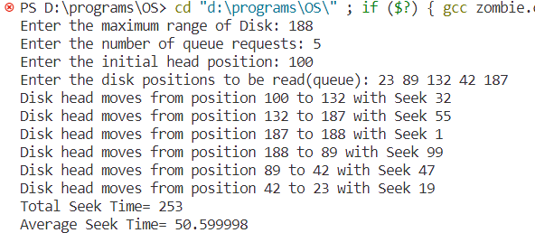

// C-SCAN
#include <stdio.h>
#include <stdlib.h>
int main()
{
int i, j, n, TotalHeadMoment = 0, initial, size, move;
printf("Enter the number of Requests\n");
scanf("%d", &n);
int RQ[n];
printf("Enter the Requests sequence\n");
for (i = 0; i < n; i++)
scanf("%d", &RQ[i]);
printf("Enter initial head position\n");
scanf("%d", &initial);
printf("Enter total disk size\n");
scanf("%d", &size);
printf("Enter the head movement direction for high 1 and for low 0\n");
scanf("%d", &move);
for (i = 0; i < n; i++)
{
for (j = 0; j < n - i - 1; j++)
{
if (RQ[j] > RQ[j + 1])
{
int temp;
temp = RQ[j];
RQ[j] = RQ[j + 1];
RQ[j + 1] = temp;
}
}
}
int index;
for (i = 0; i < n; i++)
{
if (initial < RQ[i])
{
index = i;
Break;
}
}
if (move == 1)
{
for (i = index; i < n; i++)
{
TotalHeadMoment = TotalHeadMoment + abs(RQ[i] - initial);
initial = RQ[i];
}
TotalHeadMoment = TotalHeadMoment + abs(size - RQ[i - 1] - 1);
TotalHeadMoment = TotalHeadMoment + abs(size - 1 - 0);
initial = 0;
for (i = 0; i < index; i++)
{
TotalHeadMoment = TotalHeadMoment + abs(RQ[i] - initial);
initial = RQ[i];
}
}
else
{
for (i = index - 1; i >= 0; i--)
{
TotalHeadMoment = TotalHeadMoment + abs(RQ[i] - initial);
initial = RQ[i];
}
TotalHeadMoment = TotalHeadMoment + abs(RQ[i + 1] - 0);
TotalHeadMoment = TotalHeadMoment + abs(size - 1 - 0);
initial = size - 1;
for (i = n - 1; i >= index; i--)
{
TotalHeadMoment = TotalHeadMoment + abs(RQ[i] - initial);
initial = RQ[i];
}
}
printf("Total Seek Value is %d\n", TotalHeadMoment);
return 0;
}
OUTPUT

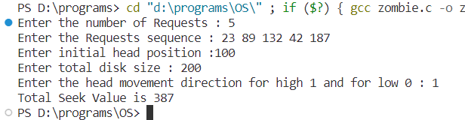

15. WAP to implement Look and C-look disk scheduling algorithm. Calculate the total seek time.

// LOOK
#include <stdio.h>
#include <stdlib.h>
int main()
{
int RQ[100], i, j, n, TotalHeadMoment = 0, initial, size, move;
printf("Enter the number of Requests\n");
scanf("%d", &n);
printf("Enter the Requests sequence\n");
for (i = 0; i < n; i++)
scanf("%d", &RQ[i]);
printf("Enter initial head position\n");
scanf("%d", &initial);
printf("Enter total disk size\n");
scanf("%d", &size);
printf("Enter the head movement direction for high 1 and for low 0\n");
scanf("%d", &move);
for (i = 0; i < n; i++)
{
for (j = 0; j < n - i - 1; j++)
{
if (RQ[j] > RQ[j + 1])
{
int temp;
temp = RQ[j];
RQ[j] = RQ[j + 1];
RQ[j + 1] = temp;
}
}
}
int index;
for (i = 0; i < n; i++)
{
if (initial < RQ[i])
{
index = i;
break;
}
}
if (move == 1)
{
for (i = index; i < n; i++)
{
TotalHeadMoment = TotalHeadMoment + abs(RQ[i] - initial);
initial = RQ[i];
}
for (i = index - 1; i >= 0; i--)
{
TotalHeadMoment = TotalHeadMoment + abs(RQ[i] - initial);
initial = RQ[i];
}
}
else
{
for (i = index - 1; i >= 0; i--)
{
TotalHeadMoment = TotalHeadMoment + abs(RQ[i] - initial);
initial = RQ[i];
}
for (i = index; i < n; i++)
{
TotalHeadMoment = TotalHeadMoment + abs(RQ[i] - initial);
initial = RQ[i];
}
}
printf("Total head movement is %d \n", TotalHeadMoment);
return 0;
}
OUTPUT

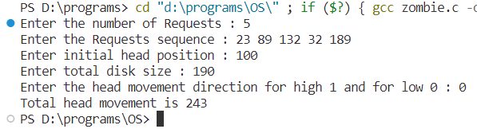
// C-LOOK
#include <stdlib.h>
#include <stdio.h>
int main()
{
int RQ[100], i, j, n, TotalHeadMoment = 0, initial, size, move;
printf("Enter the number of Requests : ");
scanf("%d", &n);
printf("Enter the Requests sequence : ");
for (i = 0; i < n; i++)
scanf("%d", &RQ[i]);
printf("Enter initial head position : ");
scanf("%d", &initial);
printf("Enter total disk size : ");
scanf("%d", &size);
printf("Enter the head movement direction for high 1 and for low 0 : ");
scanf("%d", &move);
for (i = 0; i < n; i++)
{
for (j = 0; j < n - i - 1; j++)
{
if (RQ[j] > RQ[j + 1])
{
int temp;
temp = RQ[j];
RQ[j] = RQ[j + 1];
RQ[j + 1] = temp;
}
}
}
int index;
for (i = 0; i < n; i++)
{
if (initial < RQ[i])
{
index = i;
break;
}
}
if (move == 1)
{
for (i = index; i < n; i++)
{
TotalHeadMoment = TotalHeadMoment + abs(RQ[i] - initial);
initial = RQ[i];
}
for (i = 0; i < index; i++)
{
TotalHeadMoment = TotalHeadMoment + abs(RQ[i] - initial);
initial = RQ[i];
}
}
else
{
for (i = index - 1; i >= 0; i--)
{
TotalHeadMoment = TotalHeadMoment + abs(RQ[i] - initial);
initial = RQ[i];
}
for (i = n - 1; i >= index; i--)
{
TotalHeadMoment = TotalHeadMoment + abs(RQ[i] - initial);
initial = RQ[i];
}
}
printf("Total head movement is %d\n", TotalHeadMoment);
return 0;
}
OUTPUT

